Assignment connection errors

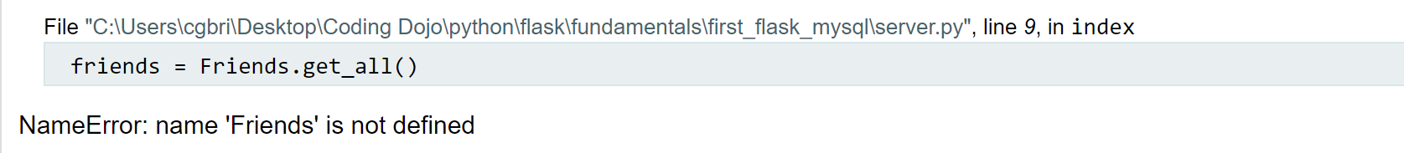

Friends should not be plural

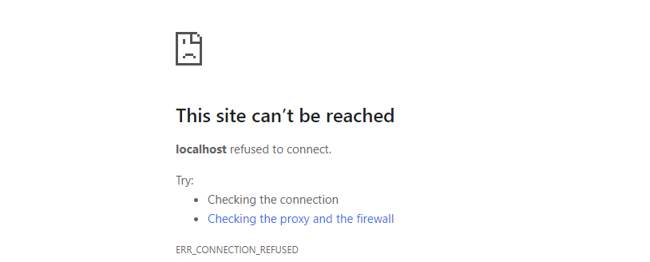

Import on server page missing



Password for connection is incorrect



User name for connection is incorrect

Completely blank page – no index file to display